**Create a Wireless LAN and Hotspot 2.0 Profile with RADIUS**

This procedure describes how to create a wireless LAN that you’ll enable with Hotspot 2.0/Passpoint.  
Hotspot 2.0 allows mobile devices to join a Wi-Fi network automatically, including during  
roaming, when the devices enter the Hotspot 2.0 area.  
Before creating a new wireless LAN for Hotspot 2.0, review the RUCKUS documentation.

**Create a wireless LAN**

1. Select Wireless LANs from the menu on the left side of the RUCKUS Dashboard.

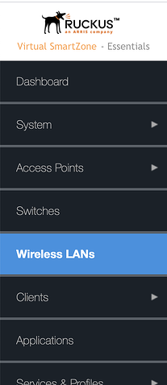

The Wireless LANs page appears.  
2. Click ➕Create

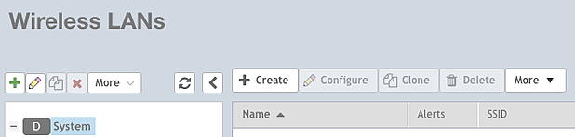

The Create WLAN Configuration dialog box appears.

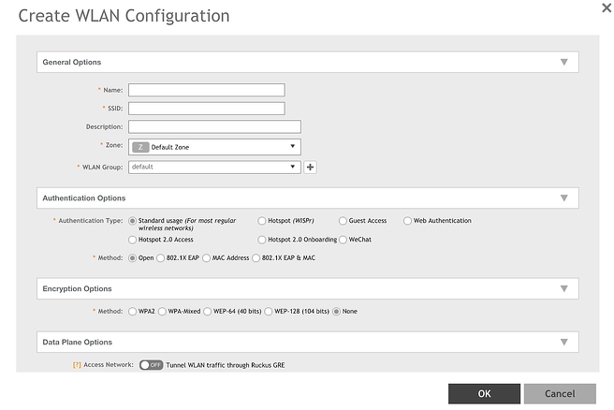

Note: There **are several options to set**. Only the options that require your input  
are shown. Default values are used for options that don’t need adjustment.

**General options**

1. Enter the name of the wireless LAN you are creating in the Name field.

2. SSID is up to you, often something like ‘**passpoint**’ etc.

3. Set the Zone and WLAN Group like you normally would allow the WLAN to propagate.

**Authentication options**

For Authentication Type, **select Hotspot 2.0 Access**. (You can’t specify Hotspot 2.0  
Onboarding because that option doesn’t give you the ability to add a Hotspot 2.0 profile.)  
**Selecting Hotspot 2.0 Access automatically** sets **Method to 802.1X EAP** and it can’t be  
changed.

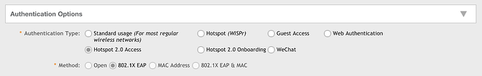

**Encryption options**  
The (encryption) Method defaults to **WPA2** and can’t be changed. **Enable 802.11r**.  
Use the default values for other fields.

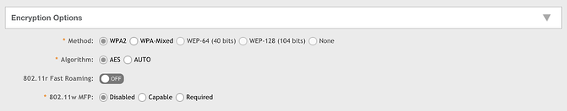

**RADIUS options: define your venue.**

**Important:**

Ameriband any **Radius Attributes** that you currently leverage, NAS ID is used here as an example to **identify site location** with  
each RADIUS access request. By default, RUCKUS uses the WLAN BSSID for the NAS ID.  
If desired replace the default with your site-specific venue name or address.

**Hotspot 2.0 Profile**

1. Set the Accounting Server update interval to 10 minutes.  
2. Click ➕to the right of Hotspot 2.0 Profile.

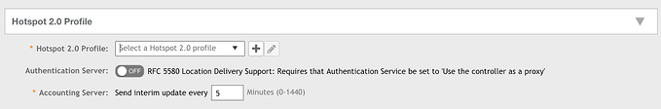

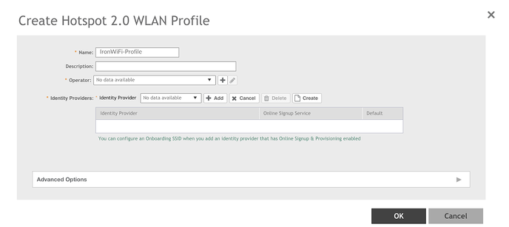

The Create **Hotspot 2.0 WLAN Profile** dialog box appears.

3. Enter the profile name in the Name field, such as “Ameriband”.

**Create Operator**

1. On the Create Hotspot 2.0 WLAN Profile dialog box, click **➕**to the right of Operator.  
The Create Hotspot 2.0 Wi-Fi Operator Profile dialog box appears. Something like **Ameriband Profile**

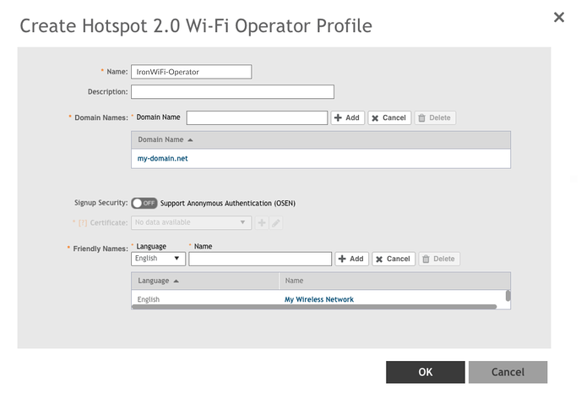

2. Enter the operator name in the Name field, for example “Ameriband-Operator”.  
3. Enter at least one Domain Name from your environment,  “Ameriband.com”(Ameriband.net).  
4. Click ➕Add to the right of Domain Name to add the domain.  
5. Enter at least one name for Friendly Names, “such as My Wireless Network”. Friendly  
names are additional descriptors. The friendly name is what a Hotspot 2.0 client sees  
on their screen.  
6. Click ➕Add to the right of the friendly name to add the friendly name.  
7. Click OK. You return to the Create Hotspot 2.0 WLAN Profile dialog box.



**Create Identity Provider**

1. On the Create Hotspot 2.0 WLAN Profile dialog box, to the right of Identity  
Provider, click Create to start the Identity Provider creation process.   
The Create Hotspot 2.0 Identity Provider dialog box appears. Network Identifier is  
selected in the top navigation.

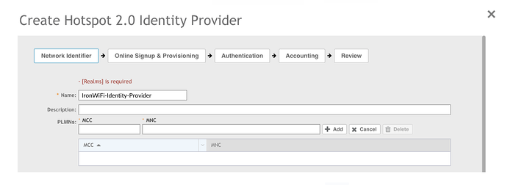

2. Enter the name of the identity provider in the Name field, such as “**T-Mobile or ATT**”.  
3. Under the PLMNs section, enter the MCC/MNC codes one entry at a time and click +Add to register each code pair.

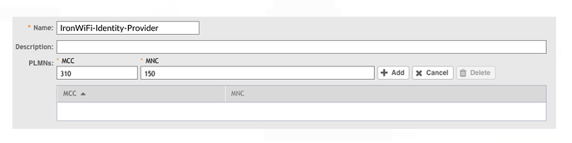

4. Add the following MCC/MNC code pairs and repeat step 3 to register each code on the  
WLC.

**T-Mobile**

MCC 310 MNC 260

MCC 312 MNC 530

MCC 310 MNC 120

**AT&T**

MCC 310 MNC 410

MCC 310 MNC 280

MCC 313 MNC 100

MCC 310 MNC 150

You should see a list of number like below.

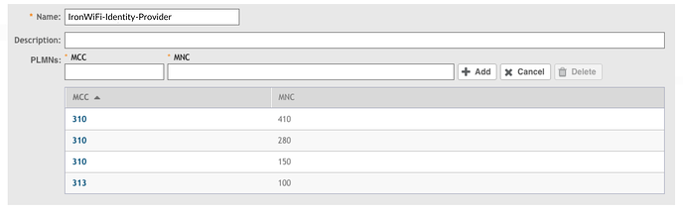

**Create RADIUS Authentication Service**

NOTE: In **“Realm”** put **premnet.wefi.com** Choose **EAP-TTLS** and **MSCHAPv2. “Home OIs”** put in **GoogleFi** as name and **F4F5E8F5F4, Ameriband**  8C1F6467B4 and code (**two digits** in each box under **Organization ID**).

This procedure describes settings for RADIUS Authentication. By default, two realms exist:  
**No Match and Unspecified.** When configured with the same RADIUS service, these two  
Authentication realms together accept all traffic for the **Ameriband Profile.**

**No additional Realms need to be created.**

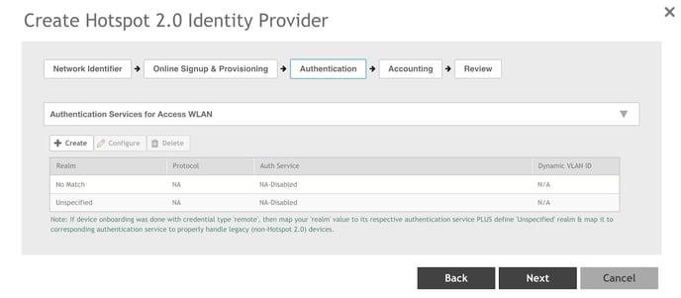

This procedure describes settings for RADIUS Authentication. you can configure all realms to  
point to the Ameriband end point for authentication and accounting. **Ameriband will provide**

unique **shared secret** and **RADIUS authentication and accounting** **ports** to be used at time of configuration.

**FQDN Radius server: radius-e.oss-ameriband.com (20.106.146.249) auth 5xxx acct 5xxx**

**FQDN Radius server: radius-w.oss-ameriband.com (13.64.130.198) auth 5xxx acct 5xxx**

 3. Click ➕next to Service. The Create Authentication Service dialog box appears.

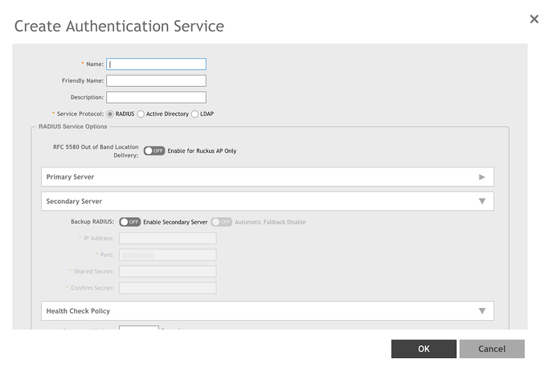

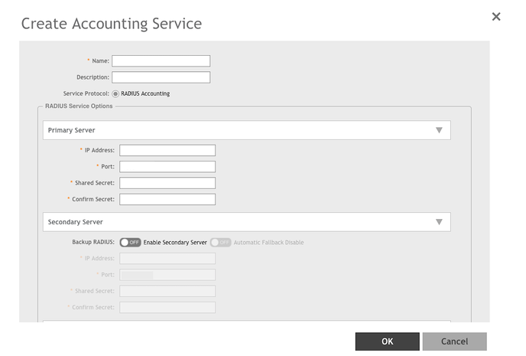

**Review is the final step** and this should complete Hotspot 2.0 configuration.



Feel free to setup a live test or configuration call with Ameriband if desired.